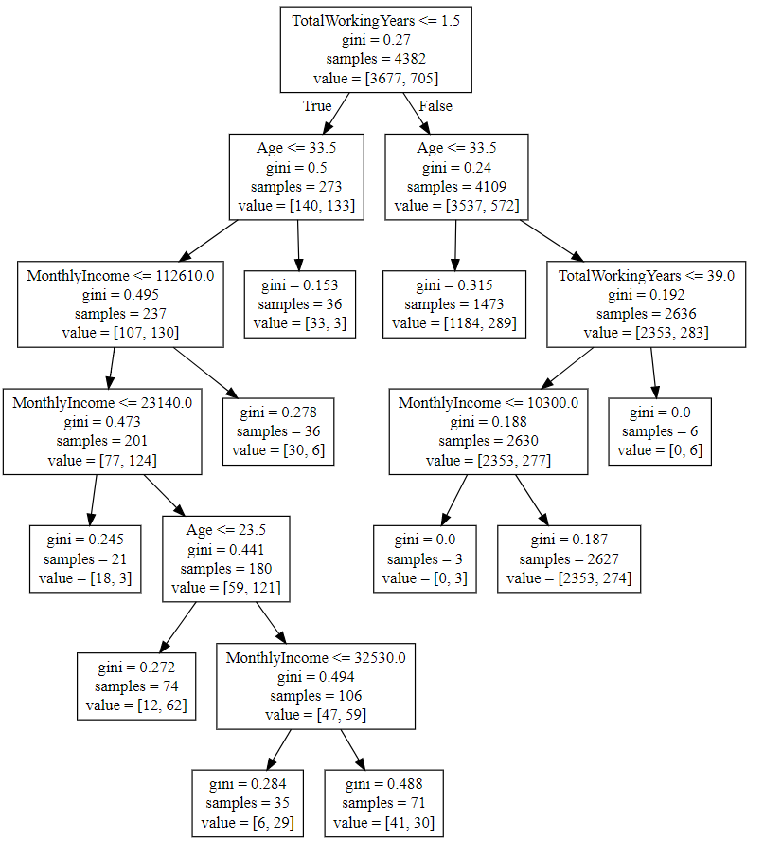

1. High attrition for employee less than 1.5 year working experience
2. Employees age between 23.5 to 33.5 years, working exp less than 1.5yrs has highest attrition
3. Employees age more than 33.5 years has less attrition
4. Employees with working experience 39yrs+ has almost 0 possibility of attrition
5. Employees age more than 33.5 years & income more than 10300, has very less chances of attrition.